ISYE 430/530 Homework Set Number 3
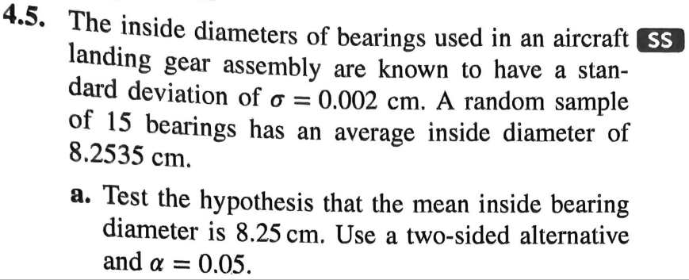
Additional part: Find the probability of not detecting a shift if the mean of the process changes from 8.25 cm to 8.255 cm.
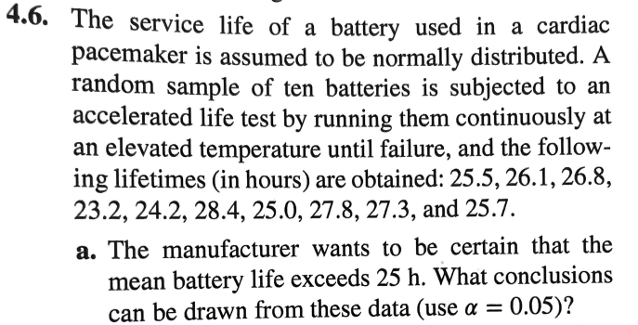
Additional Part: The manufacturer claims that the standard deviation battery life is less than 1.5 hours. What conclusions can be drawn from the above data?
